**Using a Vehicles-only Schedule**

**What can be edited**

Trips can start and end times may be edited



Trips may be removed



Pull out/pull in: Depot pull out and pull in elements can be removed and replaced. In the replacement you can change the origin for a pull out and the destination for a pull in.



Vehicle block information boxes offer editable fields: Vehicle ID and vehicle type



**Moving on or more trips to another Vehicle**

The method is the same as used in Drivers Gantt: **Moving a single trip** and **Moving Mul- tiple Trips to Another Duty**.

**Changing trip times**

Click a trip element for editing.

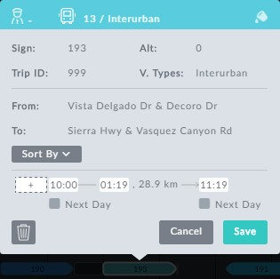

*Figure 1-1: Editing a vehicle through its information box*

Otherwise, changing trip start/end times works the same way as it does for Drivers Gant,

**Changing trip times**.

**Deleting a trip**

Deleting a trip works the same way as it does for Drivers Gant, **Deleting a Trip**.

**Changing a Depot for Pull out/Pull in**

Changing a Depot for Pull out/Pull in requires that you delete the element and replace it with a different depot. In the replaced element, you can change the depot origin for a pull out and the destination depot for a pull in.

In the following example we will change the depot for a pull out. We do it in two stages:

Ø **Stage 1 - To delete a pull out:**

1. Open its information box:

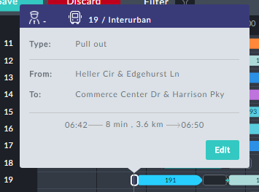

2. Click **Edit**.

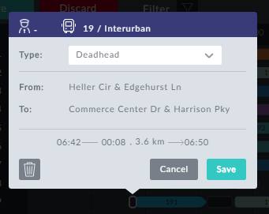

3. Click the button. The pull out is deleted.



Ø **Stage 2 -To add back the pull out with a new origin:**

1. Locate the block with the missing pull out.



It will show a red exclamtion mark to the left and a small blue plus sign when you mous-over the beginning of the trip.

2. Click the plus sign. An information box opens:

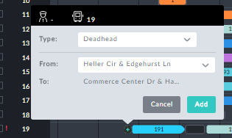

3. Click the From field. A drop list of available stops is displayed:

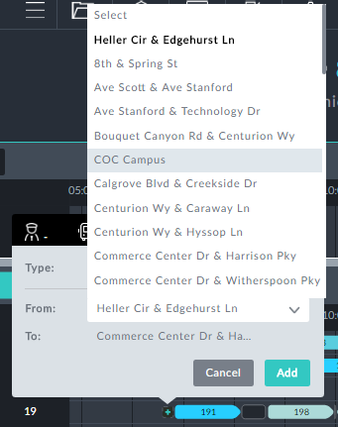

4. Choose (say) COC Campus.

5. Click **Add**. The pull out is re-instated with the new origin.

**Custom Types and Elements**

Adding custom types and elements works the same way as it does for Drivers Gantt, **Cus- tom Types and Elements.**

**Block level editing**

Block level editing works the same way as it does for Drivers Gant, **Block level editing**.